Finite Element Analysis of Flat Slab with Calcpad
─────────────────────────────────────────────────────────────────────────────────────────────────────────────────────────────
Using Bogner-Fox-Schmit (BFS) plate element [1]
Input data
Span lengths
$\vec{a}=\text{hp}\left(\left[3.6;4.2;4.2;3.6\right]\right)=\left[3.6 4.2 4.2 3.6\right]$ m , $\vec{b}=\text{hp}\left(\left[3;3.6;3\right]\right)=\left[3 3.6 3\right]$ m
Number of axes - $n_{sa}=\text{len}\left(\vec{a}\right)+1=5$ , $n_{sb}=\text{len}\left(\vec{b}\right)+1=4$
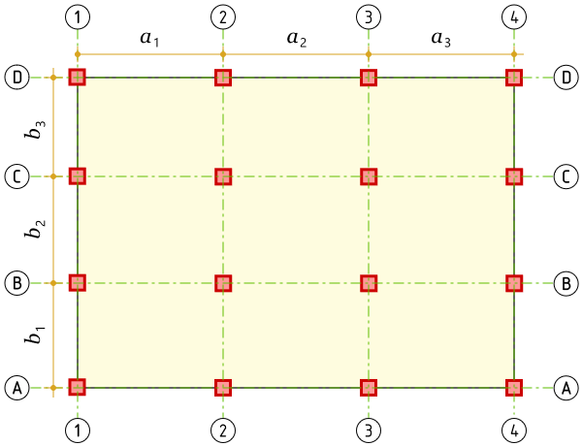
Axis coordinates - ${\vec{x}}_{s}=\left[0 3.6 7.8 12 15.6\right]$ m, ${\vec{y}}_{s}=\left[0 3 6.6 9.6\right]$ m
Slab dimensions - $l_{a}={{\vec{x}}_{s}}_{.}=15.6$ m, $l_{b}={{\vec{y}}_{s}}_{.}=9.6$ m
Thickness - $t=0.2$ m Load - $q=10$ kN/m²
Modulus of elasticity - $E=35000$ MPa Poisson`s ratio - $ν=0.2$
Finite element mesh
We will use BFS rectangular finite element with $n_{DOFs}=16$
Element dimensions - $a_{1}=0.6$ m, $b_{1}=0.6$ m
Number of elements and joints along a and b
${\vec{n}}_{a}=\text{ceiling}\left(\frac{\vec{a}}{a_{1}}\right)=\left[6 7 7 6\right]$ , $n_{ea}=\text{sum}\left({\vec{n}}_{a}\right)=26$ , $n_{ja}=n_{ea}+1=27$
${\vec{n}}_{b}=\text{ceiling}\left(\frac{\vec{b}}{b_{1}}\right)=\left[5 6 5\right]$ , $n_{eb}=\text{sum}\left({\vec{n}}_{b}\right)=16$ , $n_{jb}=n_{eb}+1=17$
Total number of elements - $n_{e}=n_{ea}·n_{eb}=416$
Total number of joints - $n_{j}=n_{ja}·n_{jb}=459$
Supported joints count - $n_{s}=n_{sa}·n_{sb}=20$
Joint coordinates
${\vec{x}}_{j}=\left[0 0 0 0 0 0 0 0 0 0 ... 15.6\right]$ m , ${\vec{y}}_{j}=\left[0 0.6 1.2 1.8 2.4 3 3.6 4.2 4.8 5.4 ... 9.6\right]$ m
Numbers of joints at elements' corners
$$\text{transp}\left(e_{j}\right)=\left[\begin{matrix}1 & 2 & 3 & 4 & 5 & 6 & 7 & 8 & 9 & 10 & ⋯ & 441 \\ 18 & 19 & 20 & 21 & 22 & 23 & 24 & 25 & 26 & 27 & ⋯ & 458 \\ 19 & 20 & 21 & 22 & 23 & 24 & 25 & 26 & 27 & 28 & ⋯ & 459 \\ 2 & 3 & 4 & 5 & 6 & 7 & 8 & 9 & 10 & 11 & ⋯ & 442\end{matrix}\right]$$
Supported joints - ${\vec{s}}_{j}=\left[1 6 12 17 103 108 114 119 222 227 ... 459\right]$
Joints for element e - $j_{e}\left(e\right)=\text{row}\left(e_{j};e\right)$
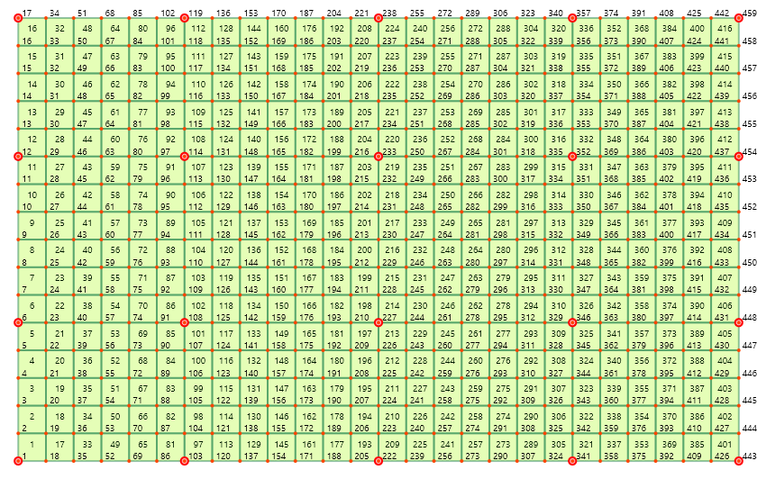
Finite element formulation
Shape functions
Along dimension a
Base functions  $$Φ_{1a}\left(ξ\right)=1-ξ^{2}·\left(3-2·ξ\right)$$  $$Φ_{2a}\left(ξ\right)=ξ·a_{1}·\left(1-ξ·\left(2-ξ\right)\right)$$  $$Φ_{3a}\left(ξ\right)=ξ^{2}·\left(3-2·ξ\right)$$  $$Φ_{4a}\left(ξ\right)=ξ^{2}·a_{1}·\left(\text{-}1+ξ\right)$$ | First derivatives  $${Φ'}_{1a}\left(ξ\right)=\text{-}6·\frac{ξ}{a_{1}}·\left(1-ξ\right)$$  $${Φ'}_{2a}\left(ξ\right)=1-ξ·\left(4-3·ξ\right)$$  $${Φ'}_{3a}\left(ξ\right)=6·\frac{ξ}{a_{1}}·\left(1-ξ\right)$$  $${Φ'}_{4a}\left(ξ\right)=\text{-}ξ·\left(2-3·ξ\right)$$ | Second derivatives  $${Φ″}_{1a}\left(ξ\right)=\text{-}\frac{6}{{a_{1}}^{2}}·\left(1-2·ξ\right)$$  $${Φ″}_{2a}\left(ξ\right)=\text{-}\frac{2}{a_{1}}·\left(2-3·ξ\right)$$  $${Φ″}_{3a}\left(ξ\right)=\frac{6}{{a_{1}}^{2}}·\left(1-2·ξ\right)$$  $${Φ″}_{4a}\left(ξ\right)=\text{-}\frac{2}{a_{1}}·\left(1-3·ξ\right)$$
Along dimension b
Base functions  $$Φ_{1b}\left(η\right)=1-η^{2}·\left(3-2·η\right)$$  $$Φ_{2b}\left(η\right)=η·b_{1}·\left(1-η·\left(2-η\right)\right)$$  $$Φ_{3b}\left(η\right)=η^{2}·\left(3-2·η\right)$$  $$Φ_{4b}\left(η\right)=η^{2}·b_{1}·\left(\text{-}1+η\right)$$ | First derivatives  $${Φ'}_{1b}\left(η\right)=\text{-}6·\frac{η}{b_{1}}·\left(1-η\right)$$  $${Φ'}_{2b}\left(η\right)=1-η·\left(4-3·η\right)$$  $${Φ'}_{3b}\left(η\right)=6·\frac{η}{b_{1}}·\left(1-η\right)$$  $${Φ'}_{4b}\left(η\right)=\text{-}η·\left(2-3·η\right)$$ |  | Second derivatives  $${Φ″}_{1b}\left(η\right)=\text{-}\frac{6}{{b_{1}}^{2}}·\left(1-2·η\right)$$  $${Φ″}_{2b}\left(η\right)=\text{-}\frac{2}{b_{1}}·\left(2-3·η\right)$$  $${Φ″}_{3b}\left(η\right)=\frac{6}{{b_{1}}^{2}}·\left(1-2·η\right)$$  $${Φ″}_{4b}\left(η\right)=\text{-}\frac{2}{b_{1}}·\left(1-3·η\right)$$
For vertical displacements  $$N_{1,w}\left(ξ;η\right)=Φ_{1a}\left(ξ\right)·Φ_{1b}\left(η\right)$$  $$N_{2,w}\left(ξ;η\right)=Φ_{3a}\left(ξ\right)·Φ_{1b}\left(η\right)$$  $$N_{3,w}\left(ξ;η\right)=Φ_{3a}\left(ξ\right)·Φ_{3b}\left(η\right)$$  $$N_{4,w}\left(ξ;η\right)=Φ_{1a}\left(ξ\right)·Φ_{3b}\left(η\right)$$ | For rotations θₓ  $$N_{1,θₓ}\left(ξ;η\right)=Φ_{2a}\left(ξ\right)·Φ_{1b}\left(η\right)$$  $$N_{2,θₓ}\left(ξ;η\right)=Φ_{4a}\left(ξ\right)·Φ_{1b}\left(η\right)$$  $$N_{3,θₓ}\left(ξ;η\right)=Φ_{4a}\left(ξ\right)·Φ_{3b}\left(η\right)$$  $$N_{4,θₓ}\left(ξ;η\right)=Φ_{2a}\left(ξ\right)·Φ_{3b}\left(η\right)$$ |  | For rotations θᵧ  $$N_{1,θᵧ}\left(ξ;η\right)=Φ_{1a}\left(ξ\right)·Φ_{2b}\left(η\right)$$  $$N_{2,θᵧ}\left(ξ;η\right)=Φ_{3a}\left(ξ\right)·Φ_{2b}\left(η\right)$$  $$N_{3,θᵧ}\left(ξ;η\right)=Φ_{3a}\left(ξ\right)·Φ_{4b}\left(η\right)$$  $$N_{4,θᵧ}\left(ξ;η\right)=Φ_{1a}\left(ξ\right)·Φ_{4b}\left(η\right)$$
For twist ψ  $$N_{1,ψ}\left(ξ;η\right)=Φ_{2a}\left(ξ\right)·Φ_{2b}\left(η\right)$$  $$N_{2,ψ}\left(ξ;η\right)=Φ_{4a}\left(ξ\right)·Φ_{2b}\left(η\right)$$  $$N_{3,ψ}\left(ξ;η\right)=Φ_{4a}\left(ξ\right)·Φ_{4b}\left(η\right)$$  $$N_{4,ψ}\left(ξ;η\right)=Φ_{2a}\left(ξ\right)·Φ_{4b}\left(η\right)$$ | 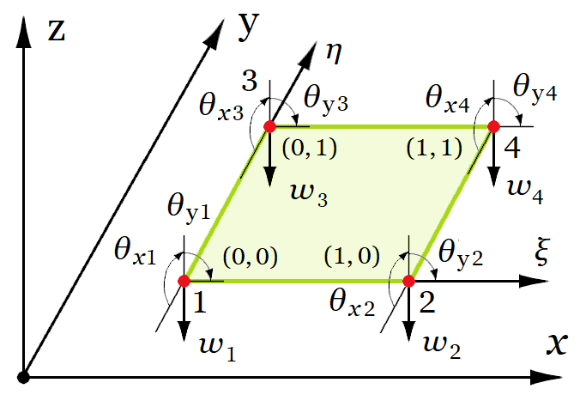
N_{1,w} shape function plot  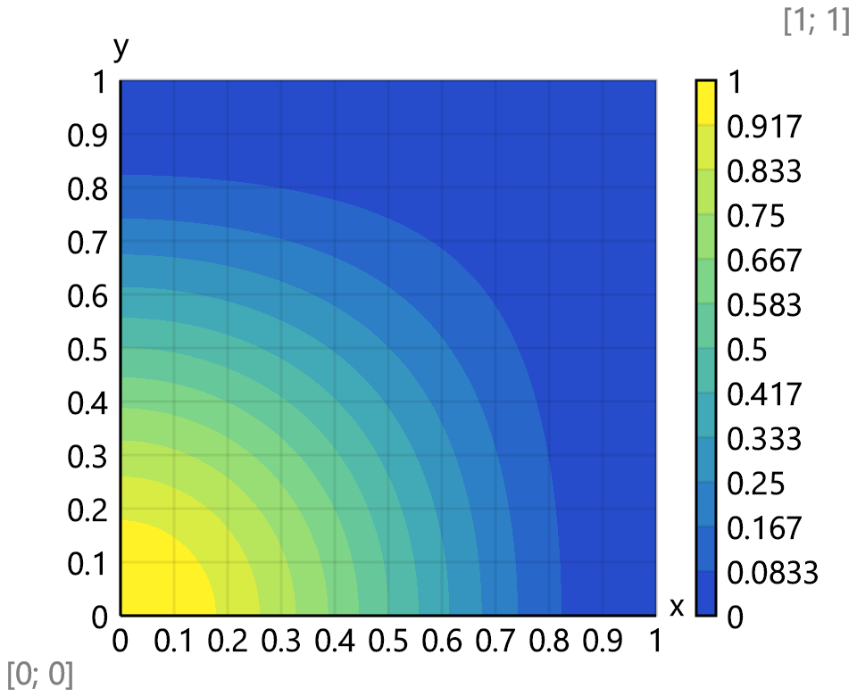 |  | N_{1,θx} shape function plot  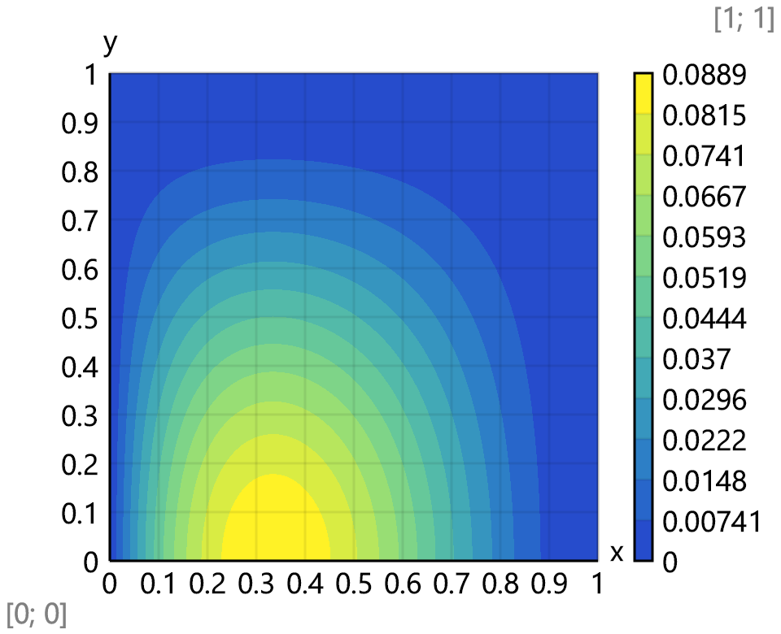
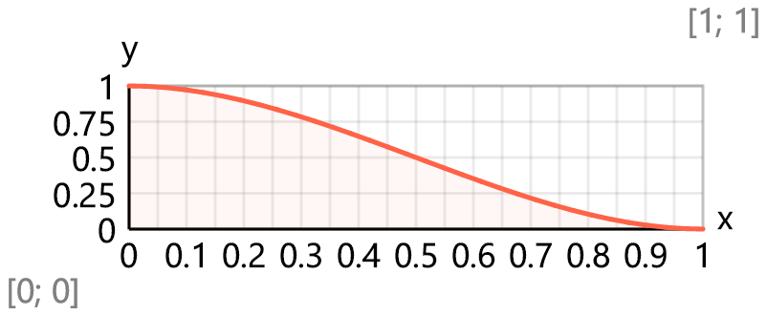 |  | 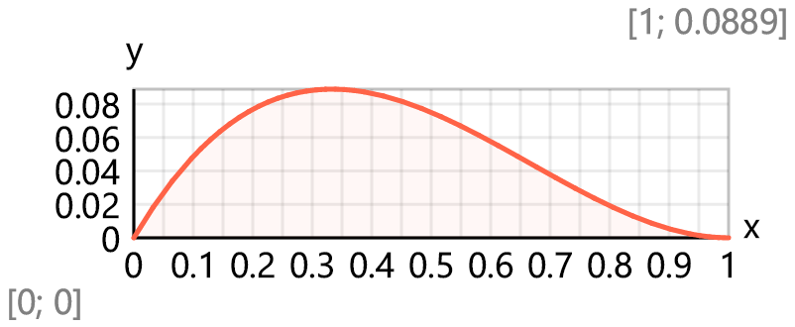
Shape functions vector $N\left(i;ξ;η\right)=\text{take}\left(\begin{aligned}i; N_{1,w}\left(ξ;η\right);N_{1,θₓ}\left(ξ;η\right);N_{1,θᵧ}\left(ξ;η\right);N_{1,ψ}\left(ξ;η\right); \\ N_{2,w}\left(ξ;η\right);N_{2,θₓ}\left(ξ;η\right);N_{2,θᵧ}\left(ξ;η\right);N_{2,ψ}\left(ξ;η\right); \\ N_{3,w}\left(ξ;η\right);N_{3,θₓ}\left(ξ;η\right);N_{3,θᵧ}\left(ξ;η\right);N_{3,ψ}\left(ξ;η\right); \\ { N}_{4,w}\left(ξ;η\right);N_{4,θₓ}\left(ξ;η\right);N_{4,θᵧ}\left(ξ;η\right);N_{4,ψ}\left(ξ;η\right)\end{aligned}\right)$
Constitutive matrix (stress - strain relationship)
$D=\frac{E·t^{3}}{12·\left(1-ν^{2}\right)}·\text{hp}\left(\left[1;ν;0 | ν;1;0 | 0;0;\frac{1-ν}{2}\right]\right)=\left[\begin{matrix}24.31 & 4.86 & 0 \\ 4.86 & 24.31 & 0 \\ 0 & 0 & 9.72\end{matrix}\right]$ kNm
Strain-displacement matrix
$$B_{1}\left(j;ξ;η\right)=\text{take}\left(j;{Φ″}_{1a}\left(ξ\right)·Φ_{1b}\left(η\right);{Φ″}_{2a}\left(ξ\right)·Φ_{1b}\left(η\right);{Φ″}_{1a}\left(ξ\right)·Φ_{2b}\left(η\right);{Φ″}_{2a}\left(ξ\right)·Φ_{2b}\left(η\right);{Φ″}_{3a}\left(ξ\right)·Φ_{1b}\left(η\right);{Φ″}_{4a}\left(ξ\right)·Φ_{1b}\left(η\right);{Φ″}_{3a}\left(ξ\right)·Φ_{2b}\left(η\right);{Φ″}_{4a}\left(ξ\right)·Φ_{2b}\left(η\right);{Φ″}_{3a}\left(ξ\right)·Φ_{3b}\left(η\right);{Φ″}_{4a}\left(ξ\right)·Φ_{3b}\left(η\right);{Φ″}_{3a}\left(ξ\right)·Φ_{4b}\left(η\right);{Φ″}_{4a}\left(ξ\right)·Φ_{4b}\left(η\right);{Φ″}_{1a}\left(ξ\right)·Φ_{3b}\left(η\right);{Φ″}_{2a}\left(ξ\right)·Φ_{3b}\left(η\right);{Φ″}_{1a}\left(ξ\right)·Φ_{4b}\left(η\right);{Φ″}_{2a}\left(ξ\right)·Φ_{4b}\left(η\right)\right)$$
$$B_{2}\left(j;ξ;η\right)=\text{take}\left(j;Φ_{1a}\left(ξ\right)·{Φ″}_{1b}\left(η\right);Φ_{2a}\left(ξ\right)·{Φ″}_{1b}\left(η\right);Φ_{1a}\left(ξ\right)·{Φ″}_{2b}\left(η\right);Φ_{2a}\left(ξ\right)·{Φ″}_{2b}\left(η\right);Φ_{3a}\left(ξ\right)·{Φ″}_{1b}\left(η\right);Φ_{4a}\left(ξ\right)·{Φ″}_{1b}\left(η\right);Φ_{3a}\left(ξ\right)·{Φ″}_{2b}\left(η\right);Φ_{4a}\left(ξ\right)·{Φ″}_{2b}\left(η\right);Φ_{3a}\left(ξ\right)·{Φ″}_{3b}\left(η\right);Φ_{4a}\left(ξ\right)·{Φ″}_{3b}\left(η\right);Φ_{3a}\left(ξ\right)·{Φ″}_{4b}\left(η\right);Φ_{4a}\left(ξ\right)·{Φ″}_{4b}\left(η\right);Φ_{1a}\left(ξ\right)·{Φ″}_{3b}\left(η\right);Φ_{2a}\left(ξ\right)·{Φ″}_{3b}\left(η\right);Φ_{1a}\left(ξ\right)·{Φ″}_{4b}\left(η\right);Φ_{2a}\left(ξ\right)·{Φ″}_{4b}\left(η\right)\right)$$
$$B_{3}\left(j;ξ;η\right)=2·\text{take}\left(j;{Φ'}_{1a}\left(ξ\right)·{Φ'}_{1b}\left(η\right);{Φ'}_{2a}\left(ξ\right)·{Φ'}_{1b}\left(η\right);{Φ'}_{1a}\left(ξ\right)·{Φ'}_{2b}\left(η\right);{Φ'}_{2a}\left(ξ\right)·{Φ'}_{2b}\left(η\right);{Φ'}_{3a}\left(ξ\right)·{Φ'}_{1b}\left(η\right);{Φ'}_{4a}\left(ξ\right)·{Φ'}_{1b}\left(η\right);{Φ'}_{3a}\left(ξ\right)·{Φ'}_{2b}\left(η\right);{Φ'}_{4a}\left(ξ\right)·{Φ'}_{2b}\left(η\right);{Φ'}_{3a}\left(ξ\right)·{Φ'}_{3b}\left(η\right);{Φ'}_{4a}\left(ξ\right)·{Φ'}_{3b}\left(η\right);{Φ'}_{3a}\left(ξ\right)·{Φ'}_{4b}\left(η\right);{Φ'}_{4a}\left(ξ\right)·{Φ'}_{4b}\left(η\right);{Φ'}_{1a}\left(ξ\right)·{Φ'}_{3b}\left(η\right);{Φ'}_{2a}\left(ξ\right)·{Φ'}_{3b}\left(η\right);{Φ'}_{1a}\left(ξ\right)·{Φ'}_{4b}\left(η\right);{Φ'}_{2a}\left(ξ\right)·{Φ'}_{4b}\left(η\right)\right)$$
$$B\left(j;ξ;η\right)=\text{hp}\left(\left[B_{1}\left(j;ξ;η\right);B_{2}\left(j;ξ;η\right);B_{3}\left(j;ξ;η\right)\right]\right)$$
The coefficients of the stiffness matrix will be calculated by using the equation
$$K_{e,ij}=a_{1}·b_{1}·\int_{0}^{1}{\int_{0}^{1}{{B_{i}\left(ξ;η\right)}^{T}·D·B_{j}\left(ξ;η\right) dξ} dη}$$
Element stiffness matrix – numerical evaluation
$${BTDB}_{e}\left(i;j;ξ;η\right)=\text{transp}\left(B\left(i;ξ;η\right)\right)·D·B\left(j;ξ;η\right)$$
$$K_{e}\left(i;j\right)=a_{1}·b_{1}·\int_{0}^{1}{\int_{0}^{1}{{BTDB}_{e}\left(i;j;ξ;η\right) dη} dξ}$$
$$\$Repeat\left\{\$Repeat\left\{{K_{e}}_{.i,j}=K_{e}\left(i;j\right);j=i...n\right\};i=1...n\right\}$$
$$K_{e}=\left[\begin{matrix}796.3 & 135.19 & 135.19 & 16.74 & \text{-}391.2 & 84.95 & \text{-}13.66 & 4.1 & \text{-}13.89 & 36.57 & ⋯ & 4.1 \\ 0 & 46.67 & 21.6 & 4.67 & \text{-}84.95 & 14.03 & \text{-}4.09 & 0.708 & \text{-}36.57 & 10.28 & ⋯ & \text{-}0.583 \\ 0 & 0 & 46.67 & 4.67 & \text{-}13.66 & 4.09 & 1.94 & \text{-}0.583 & \text{-}36.57 & 8.54 & ⋯ & 0.708 \\ 0 & 0 & 0 & 0.978 & \text{-}4.1 & 0.708 & 0.583 & \text{-}0.161 & \text{-}8.54 & 1.62 & ⋯ & \text{-}0.161 \\ 0 & 0 & 0 & 0 & 796.3 & \text{-}135.19 & 135.19 & \text{-}16.74 & \text{-}391.2 & 13.66 & ⋯ & 8.54 \\ 0 & 0 & 0 & 0 & 0 & 46.67 & \text{-}21.6 & 4.67 & 13.66 & 1.94 & ⋯ & \text{-}1.62 \\ 0 & 0 & 0 & 0 & 0 & 0 & 46.67 & \text{-}4.67 & \text{-}84.95 & 4.1 & ⋯ & 1.62 \\ 0 & 0 & 0 & 0 & 0 & 0 & 0 & 0.978 & 4.1 & 0.583 & ⋯ & \text{-}0.231 \\ 0 & 0 & 0 & 0 & 0 & 0 & 0 & 0 & 796.3 & \text{-}135.19 & ⋯ & 4.1 \\ 0 & 0 & 0 & 0 & 0 & 0 & 0 & 0 & 0 & 46.67 & ⋯ & \text{-}0.708 \\ ⋮ & ⋮ & ⋮ & ⋮ & ⋮ & ⋮ & ⋮ & ⋮ & ⋮ & ⋮ & ⋱ & ⋮ \\ 0 & 0 & 0 & 0 & 0 & 0 & 0 & 0 & 0 & 0 & ⋯ & 0.978\end{matrix}\right]$$
Element load vector
$$F_{e,i}=a_{1}·b_{1}·\int_{0}^{1}{\int_{0}^{1}{{N_{i}\left(ξ;η\right)}^{T}·q dξ} dη}$$
${\vec{F}}_{e}=\left[0.9 0.09 0.09 0.009 0.9 \text{-}0.09 0.09 \text{-}0.009 0.9 \text{-}0.09 ... \text{-}0.009\right]$ kN
Solution
Global stiffness matrix
$$K=\left[\begin{matrix}{10}^{20} & 135.19 & 135.19 & 16.74 & \text{-}391.2 & \text{-}13.66 & 84.95 & 4.1 & 0 & 0 & ⋯ & 0 \\ 135.19 & 46.67 & 21.6 & 4.67 & \text{-}13.66 & 1.94 & 4.1 & \text{-}0.583 & 0 & 0 & ⋯ & 0 \\ 135.19 & 21.6 & 46.67 & 4.67 & \text{-}84.95 & \text{-}4.1 & 14.03 & 0.708 & 0 & 0 & ⋯ & 0 \\ 16.74 & 4.67 & 4.67 & 0.978 & \text{-}4.1 & 0.583 & 0.708 & \text{-}0.161 & 0 & 0 & ⋯ & 0 \\ \text{-}391.2 & \text{-}13.66 & \text{-}84.95 & \text{-}4.1 & 1592.59 & 270.37 & 0 & 0 & \text{-}391.2 & \text{-}13.66 & ⋯ & 0 \\ \text{-}13.66 & 1.94 & \text{-}4.1 & 0.583 & 270.37 & 93.33 & 0 & 0 & \text{-}13.66 & 1.94 & ⋯ & 0 \\ 84.95 & 4.1 & 14.03 & 0.708 & 0 & 0 & 93.33 & 9.33 & \text{-}84.95 & \text{-}4.1 & ⋯ & 0 \\ 4.1 & \text{-}0.583 & 0.708 & \text{-}0.161 & 0 & 0 & 9.33 & 1.96 & \text{-}4.1 & 0.583 & ⋯ & 0 \\ 0 & 0 & 0 & 0 & \text{-}391.2 & \text{-}13.66 & \text{-}84.95 & \text{-}4.1 & 1592.59 & 270.37 & ⋯ & 0 \\ 0 & 0 & 0 & 0 & \text{-}13.66 & 1.94 & \text{-}4.1 & 0.583 & 270.37 & 93.33 & ⋯ & 0 \\ ⋮ & ⋮ & ⋮ & ⋮ & ⋮ & ⋮ & ⋮ & ⋮ & ⋮ & ⋮ & ⋱ & ⋮ \\ 0 & 0 & 0 & 0 & 0 & 0 & 0 & 0 & 0 & 0 & ⋯ & 0.978\end{matrix}\right]$$
Global load vector
$\vec{F}=\left[0.9 0.09 0.09 0.009 1.8 0.18 0 0 1.8 0.18 ... 0.009\right]$ kN
Solution of the system of equations
$\vec{Z}=\text{slsolve}\left(K;\vec{F}\right)=\left[0 0.552 0.383 \text{-}0.416 0.203 0.373 0.265 \text{-}0.194 0.299 0.309 ... \text{-}0.416\right]$ mm

Results
Joint displacements – $\text{transp}\left(W_{z}\right)=$
$\left[\begin{matrix}0 & 0.303 & 0.488 & 0.512 & 0.383 & 0.165 & 0 & 0.139 & 0.34 & 0.469 & ⋯ & 0 \\ 0.203 & 0.419 & 0.562 & 0.581 & 0.485 & 0.337 & 0.25 & 0.31 & 0.438 & 0.531 & ⋯ & 0.203 \\ 0.299 & 0.482 & 0.605 & 0.62 & 0.537 & 0.417 & 0.35 & 0.387 & 0.485 & 0.562 & ⋯ & 0.299 \\ 0.261 & 0.461 & 0.593 & 0.608 & 0.513 & 0.375 & 0.299 & 0.342 & 0.455 & 0.542 & ⋯ & 0.261 \\ 0.121 & 0.386 & 0.55 & 0.565 & 0.443 & 0.253 & 0.138 & 0.217 & 0.381 & 0.493 & ⋯ & 0.121 \\ 0 & 0.34 & 0.527 & 0.542 & 0.404 & 0.173 & 0 & 0.135 & 0.336 & 0.463 & ⋯ & 0 \\ 0.139 & 0.398 & 0.556 & 0.566 & 0.44 & 0.247 & 0.129 & 0.206 & 0.367 & 0.478 & ⋯ & 0.139 \\ 0.299 & 0.487 & 0.608 & 0.612 & 0.511 & 0.369 & 0.287 & 0.325 & 0.433 & 0.516 & ⋯ & 0.299 \\ 0.363 & 0.526 & 0.632 & 0.635 & 0.544 & 0.42 & 0.35 & 0.376 & 0.464 & 0.536 & ⋯ & 0.363 \\ 0.299 & 0.487 & 0.608 & 0.612 & 0.511 & 0.369 & 0.287 & 0.325 & 0.433 & 0.516 & ⋯ & 0.299 \\ ⋮ & ⋮ & ⋮ & ⋮ & ⋮ & ⋮ & ⋮ & ⋮ & ⋮ & ⋮ & ⋱ & ⋮ \\ 0 & 0.303 & 0.488 & 0.512 & 0.383 & 0.165 & 0 & 0.139 & 0.34 & 0.469 & ⋯ & 0\end{matrix}\right]$ mm
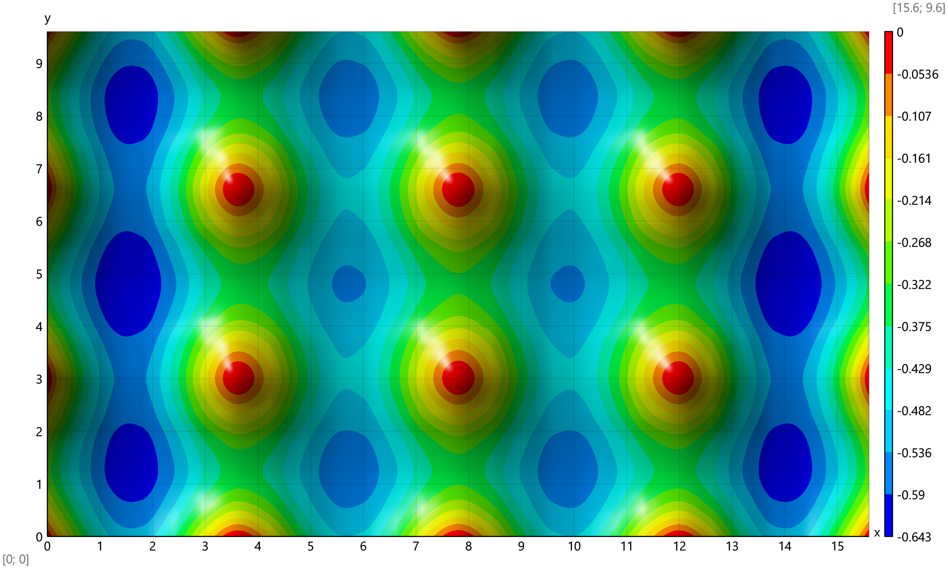
Bending moments
$$Z_{j}\left(j\right)=\text{slice}\left(\vec{Z};k_{1}·\left(j-1\right)+1;k_{1}·j\right)$$
$$Z_{e}\left(e\right)=\text{hp}\left(\left[Z_{j}\left({e_{j}}_{.e,1}\right);Z_{j}\left({e_{j}}_{.e,2}\right);Z_{j}\left({e_{j}}_{.e,3}\right);Z_{j}\left({e_{j}}_{.e,4}\right)\right]\right)$$
Average bending moments at joints, kNm/m
$$M_{j}=\left[\begin{matrix}1.5 & 0.31 & 0.22 & 0.156 & 0.157 & 0.998 & 0.156 & 0.152 & 0.194 & 0.152 & ⋯ & 1.5 \\ 1.57 & 7.81 & 9.34 & 7.67 & 3.33 & \text{-}28.36 & 3.15 & 7.32 & 8.9 & 7.32 & ⋯ & 1.57 \\ 8.09 & 3.77 & 0.486 & \text{-}2.48 & \text{-}4.46 & 0.155 & 4.78 & 2.84 & 1.19\text{×}{10}^{\text{-}8} & \text{-}2.84 & ⋯ & 8.09\end{matrix}\right]$$

Bending moments for the plate
Bending moments - M_{x} - $\text{transp}\left(Mx\right)=$
$\left[\begin{matrix}1.5 & 8.5 & 11.07 & 10.48 & 6.8 & 0.884 & \text{-}31.24 & 0.302 & 5.64 & 8.78 & ⋯ & 1.5 \\ 0.31 & 6.48 & 9.43 & 8.88 & 4.92 & \text{-}2.7 & \text{-}10.24 & \text{-}3.26 & 3.81 & 7.25 & ⋯ & 0.31 \\ 0.22 & 5.78 & 8.72 & 8.14 & 4.04 & \text{-}2.26 & \text{-}6.06 & \text{-}2.82 & 2.93 & 6.52 & ⋯ & 0.22 \\ 0.156 & 5.99 & 9.13 & 8.49 & 4.06 & \text{-}3.26 & \text{-}7.99 & \text{-}3.83 & 2.91 & 6.8 & ⋯ & 0.156 \\ 0.157 & 7.27 & 10.37 & 9.56 & 4.97 & \text{-}5.27 & \text{-}16.12 & \text{-}5.87 & 3.77 & 7.71 & ⋯ & 0.157 \\ 0.998 & 9.04 & 11.08 & 10.12 & 5.76 & \text{-}2.14 & \text{-}38.65 & \text{-}2.75 & 4.52 & 8.19 & ⋯ & 0.998 \\ 0.156 & 7.22 & 10.28 & 9.44 & 4.85 & \text{-}5.36 & \text{-}16.18 & \text{-}5.96 & 3.62 & 7.56 & ⋯ & 0.156 \\ 0.152 & 5.87 & 8.93 & 8.23 & 3.77 & \text{-}3.42 & \text{-}8.03 & \text{-}4.01 & 2.59 & 6.47 & ⋯ & 0.152 \\ 0.194 & 5.51 & 8.38 & 7.69 & 3.47 & \text{-}2.49 & \text{-}5.74 & \text{-}3.07 & 2.31 & 5.98 & ⋯ & 0.194 \\ 0.152 & 5.87 & 8.93 & 8.23 & 3.77 & \text{-}3.42 & \text{-}8.03 & \text{-}4.01 & 2.59 & 6.47 & ⋯ & 0.152 \\ ⋮ & ⋮ & ⋮ & ⋮ & ⋮ & ⋮ & ⋮ & ⋮ & ⋮ & ⋮ & ⋱ & ⋮ \\ 1.5 & 8.5 & 11.07 & 10.48 & 6.8 & 0.884 & \text{-}31.24 & 0.302 & 5.64 & 8.78 & ⋯ & 1.5\end{matrix}\right]$ kNm/m
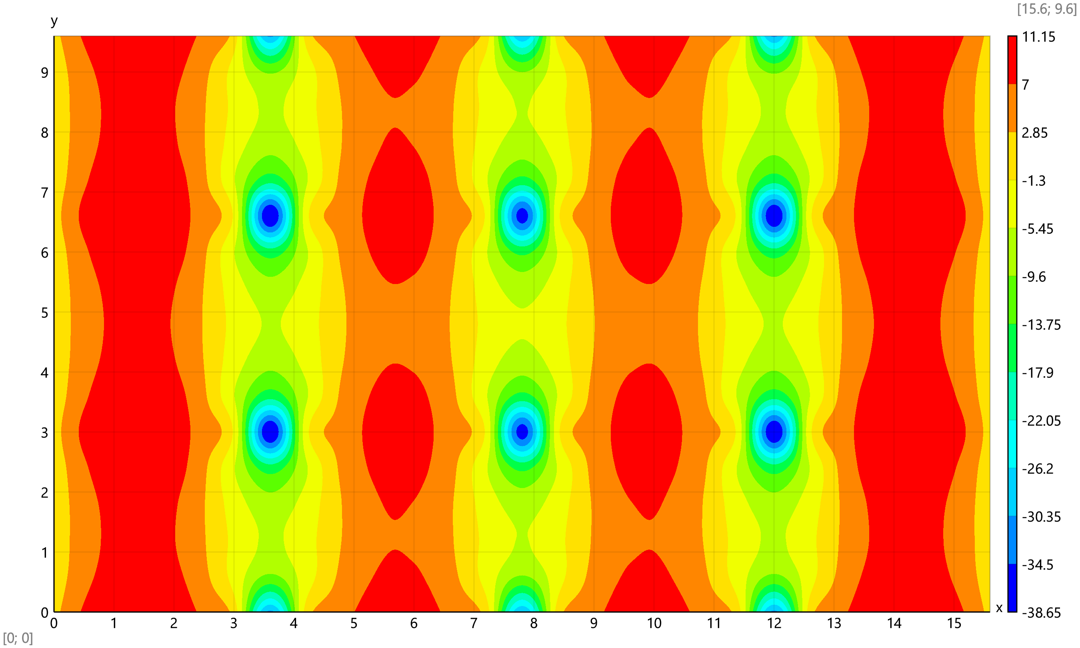
Bending moments M_{y} – $\text{transp}\left(My\right)=$
$\left[\begin{matrix}1.57 & 0.321 & 0.233 & 0.215 & 0.168 & 0.18 & 1.02 & 0.179 & 0.167 & 0.21 & ⋯ & 1.57 \\ 7.81 & 5.38 & 4.31 & 4.13 & 4.74 & 6.34 & 8.23 & 6.28 & 4.61 & 3.89 & ⋯ & 7.81 \\ 9.34 & 7.13 & 5.8 & 5.55 & 6.41 & 8.12 & 9.05 & 8.01 & 6.19 & 5.14 & ⋯ & 9.34 \\ 7.67 & 5.42 & 4.26 & 3.92 & 4.23 & 5.42 & 6.34 & 5.3 & 3.98 & 3.48 & ⋯ & 7.67 \\ 3.33 & \text{-}0.328 & 0.54 & 0.406 & \text{-}1.17 & \text{-}3.41 & \text{-}0.33 & \text{-}3.53 & \text{-}1.4 & 0.0996 & ⋯ & 3.33 \\ \text{-}28.36 & \text{-}7.04 & \text{-}1.94 & \text{-}1.65 & \text{-}4.99 & \text{-}13.64 & \text{-}36.32 & \text{-}13.77 & \text{-}5.22 & \text{-}1.86 & ⋯ & \text{-}28.36 \\ 3.15 & \text{-}0.507 & 0.349 & 0.18 & \text{-}1.46 & \text{-}3.76 & \text{-}0.723 & \text{-}3.92 & \text{-}1.77 & \text{-}0.252 & ⋯ & 3.15 \\ 7.32 & 5.09 & 3.91 & 3.49 & 3.68 & 4.69 & 5.5 & 4.48 & 3.25 & 2.79 & ⋯ & 7.32 \\ 8.9 & 6.74 & 5.35 & 4.96 & 5.61 & 6.91 & 7.57 & 6.69 & 5.14 & 4.18 & ⋯ & 8.9 \\ 7.32 & 5.09 & 3.91 & 3.49 & 3.68 & 4.69 & 5.5 & 4.48 & 3.25 & 2.79 & ⋯ & 7.32 \\ ⋮ & ⋮ & ⋮ & ⋮ & ⋮ & ⋮ & ⋮ & ⋮ & ⋮ & ⋮ & ⋱ & ⋮ \\ 1.57 & 0.32 & 0.233 & 0.215 & 0.168 & 0.18 & 1.02 & 0.179 & 0.167 & 0.21 & ⋯ & 1.57\end{matrix}\right]$ kNm/m
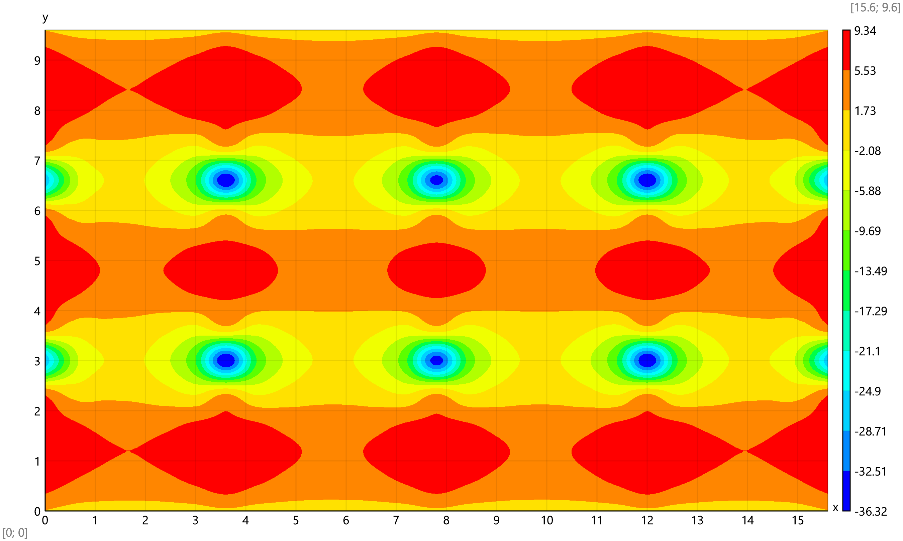
Bending moments M_{xy} – $\text{transp}\left(Mxy\right)=$
$\left[\begin{matrix}8.09 & 4.11 & 1.42 & \text{-}0.946 & \text{-}3.23 & \text{-}4.78 & 0.0218 & 4.84 & 3.34 & 1.14 & ⋯ & \text{-}8.09 \\ 3.77 & 2.57 & 0.983 & \text{-}0.516 & \text{-}2.06 & \text{-}3.23 & 0.0582 & 3.35 & 2.21 & 0.731 & ⋯ & \text{-}3.77 \\ 0.486 & 0.367 & 0.21 & 0.0857 & \text{-}0.12 & \text{-}0.314 & 0.0735 & 0.461 & 0.267 & 0.0568 & ⋯ & \text{-}0.486 \\ \text{-}2.48 & \text{-}1.8 & \text{-}0.601 & 0.617 & 1.75 & 2.09 & 0.0763 & \text{-}1.95 & \text{-}1.63 & \text{-}0.581 & ⋯ & 2.48 \\ \text{-}4.46 & \text{-}3.24 & \text{-}0.898 & 0.683 & 2.37 & 4.52 & 0.0758 & \text{-}4.38 & \text{-}2.26 & \text{-}0.682 & ⋯ & 4.46 \\ 0.155 & 0.161 & 0.149 & 0.125 & 0.0964 & 0.078 & 0.0739 & 0.0699 & 0.0513 & 0.0211 & ⋯ & \text{-}0.155 \\ 4.78 & 3.57 & 1.19 & \text{-}0.451 & \text{-}2.21 & \text{-}4.4 & 0.0635 & 4.54 & 2.38 & 0.725 & ⋯ & \text{-}4.78 \\ 2.84 & 2.13 & 0.868 & \text{-}0.438 & \text{-}1.68 & \text{-}2.08 & 0.0378 & 2.17 & 1.8 & 0.63 & ⋯ & \text{-}2.84 \\ 0 & \text{0} & \text{0} & 0 & 0 & \text{0} & 0 & \text{0} & 0 & 0 & ⋯ & \text{-}0 \\ \text{-}2.84 & \text{-}2.13 & \text{-}0.868 & 0.438 & 1.68 & 2.08 & \text{-}0.0378 & \text{-}2.17 & \text{-}1.8 & \text{-}0.63 & ⋯ & 2.84 \\ ⋮ & ⋮ & ⋮ & ⋮ & ⋮ & ⋮ & ⋮ & ⋮ & ⋮ & ⋮ & ⋱ & ⋮ \\ \text{-}8.09 & \text{-}4.11 & \text{-}1.42 & 0.946 & 3.23 & 4.78 & \text{-}0.0218 & \text{-}4.84 & \text{-}3.34 & \text{-}1.14 & ⋯ & 8.09\end{matrix}\right]$ kNm/m
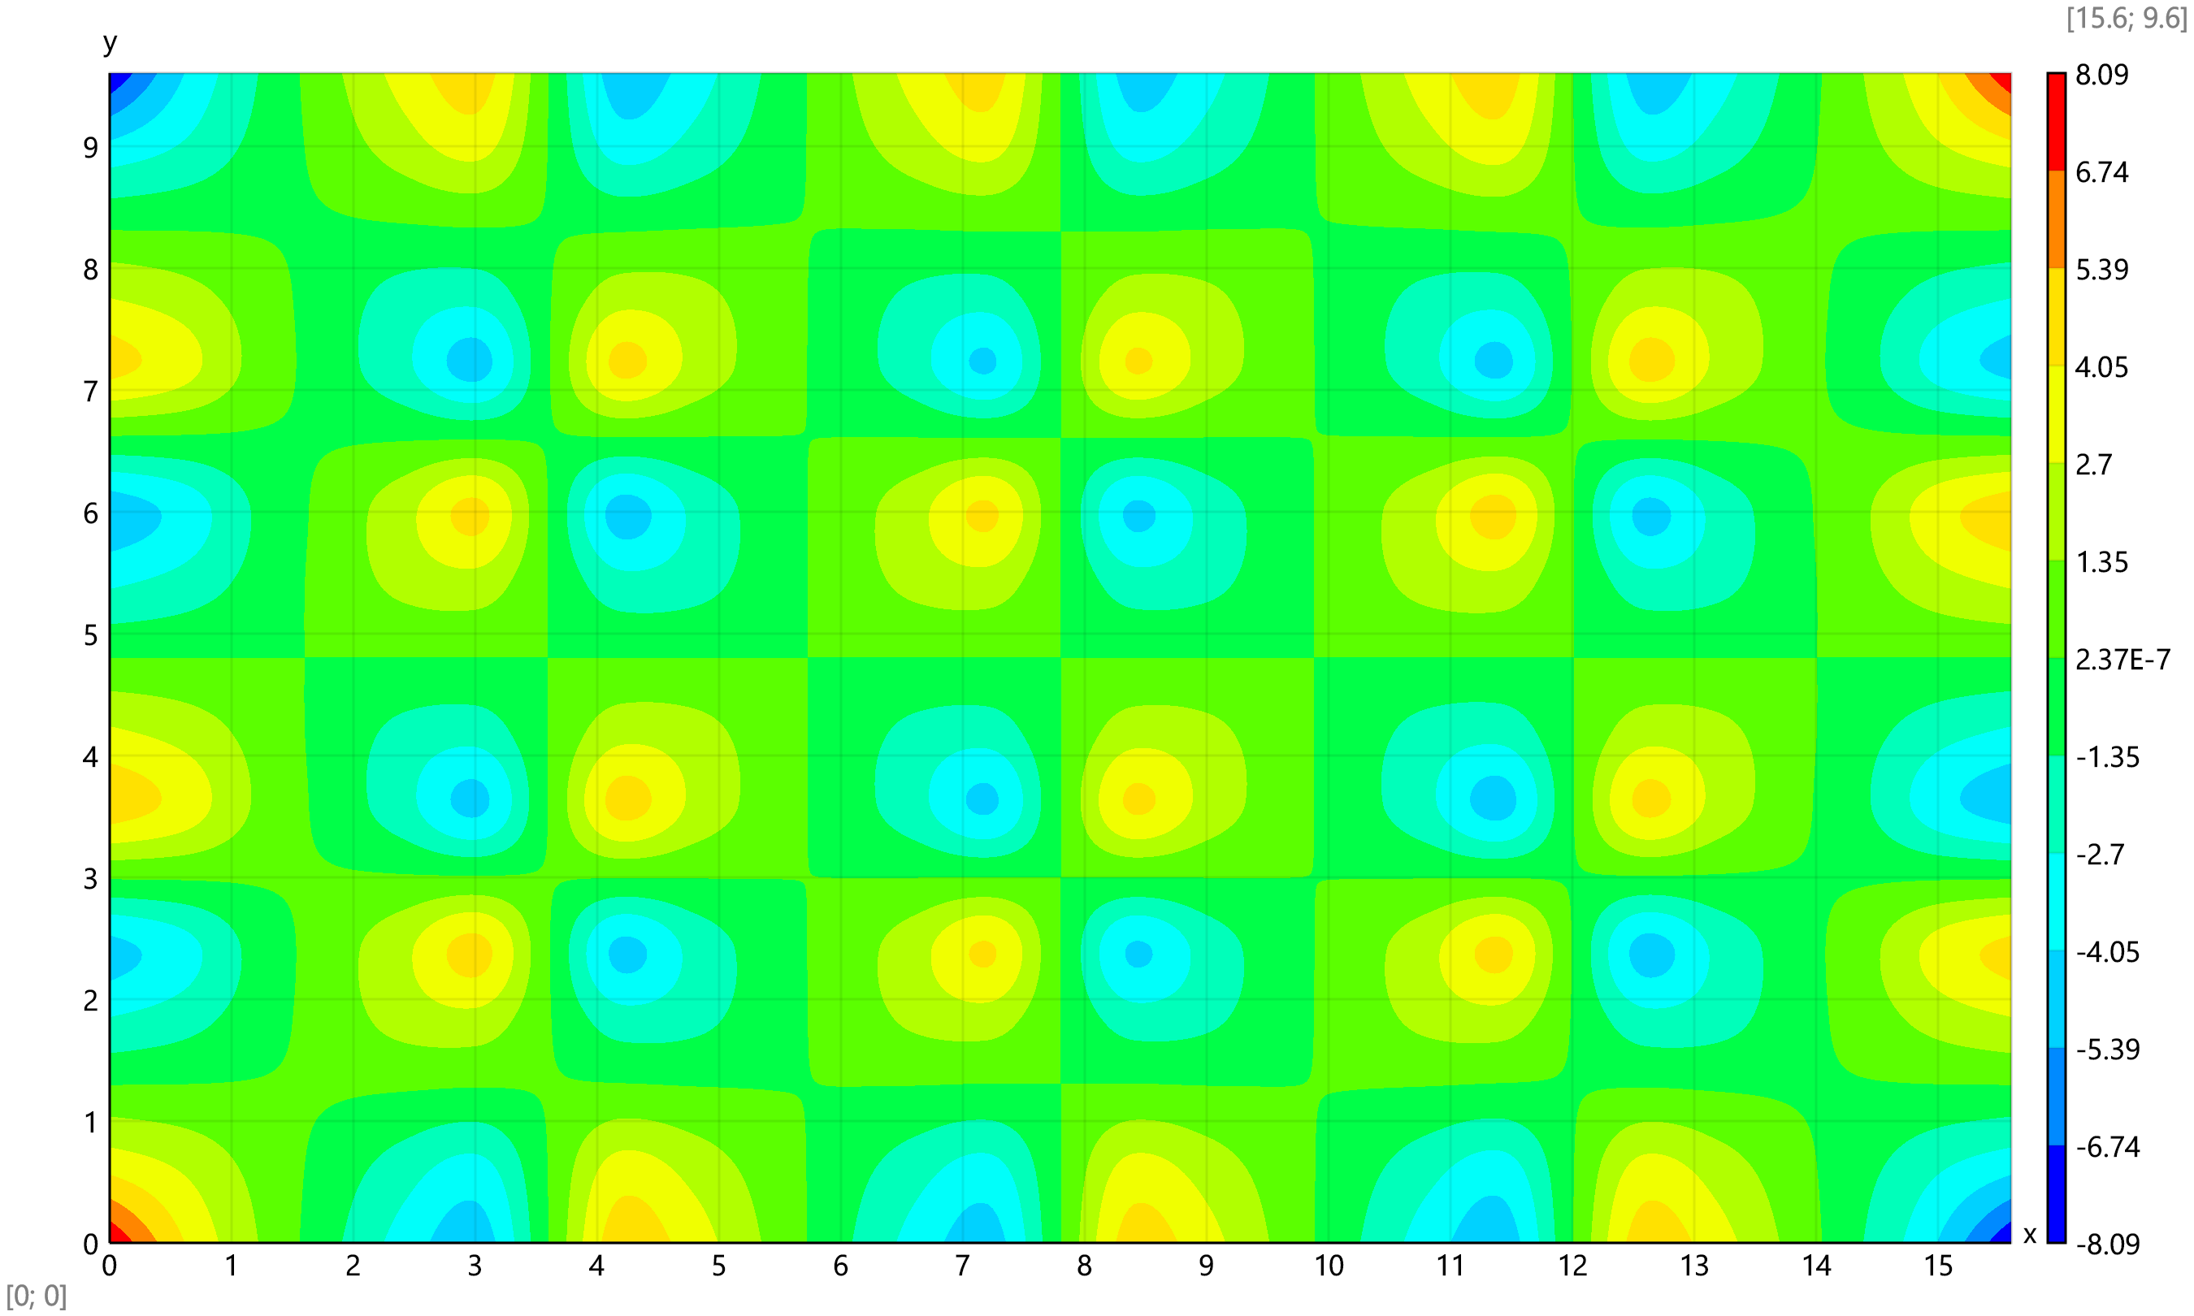
Element stiffness matrix calculation by analytical expressions (faster)
$$α=\frac{b_{1}}{a_{1}}=1$$
$${K_{e}}_{1, 1}=\frac{156}{35}·\left(\frac{α}{{a_{1}}^{2}}+\frac{1}{α·{b_{1}}^{2}}\right)+\frac{72}{25·A_{1}}=32.76$$
${K_{e}}_{5, 5}={K_{e}}_{1, 1}$ , ${K_{e}}_{9, 9}={K_{e}}_{1, 1}$ , ${K_{e}}_{13, 13}={K_{e}}_{1, 1}$
$${K_{e}}_{1, 2}=\frac{2}{35}·\left(\frac{39·α}{a_{1}}+\frac{11}{α²·b_{1}}\right)+\frac{30·ν+6}{25·b_{1}}=5.56$$
${K_{e}}_{5, 6}=\text{-}{K_{e}}_{1, 2}$ , ${K_{e}}_{9, 10}=\text{-}{K_{e}}_{1, 2}$ , ${K_{e}}_{13, 14}={K_{e}}_{1, 2}$
$${K_{e}}_{1, 3}=\frac{2}{35}·\left(\frac{11·α²}{a_{1}}+\frac{39}{α·b_{1}}\right)+\frac{30·ν+6}{25·a_{1}}=5.56$$
${K_{e}}_{5, 7}={K_{e}}_{1, 3}$ , ${K_{e}}_{9, 11}=\text{-}{K_{e}}_{1, 3}$ , ${K_{e}}_{13, 15}=\text{-}{K_{e}}_{1, 3}$
$${K_{e}}_{1, 4}=\frac{11}{35}·\left(α²+\frac{1}{α²}\right)+\frac{10·ν+1}{50}=0.689$$
${K_{e}}_{5, 8}=\text{-}{K_{e}}_{1, 4}$ , ${K_{e}}_{9, 12}={K_{e}}_{1, 4}$ , ${K_{e}}_{13, 16}=\text{-}{K_{e}}_{1, 4}$
$${K_{e}}_{1, 5}=\frac{2}{35}·\left(\frac{27}{α·{b_{1}}^{2}}-\frac{78·α}{{a_{1}}^{2}}\right)-\frac{72}{25·A_{1}}=\text{-}16.1$$
$${K_{e}}_{9, 13}={K_{e}}_{1, 5}$$
$${K_{e}}_{1, 6}=\frac{13}{35}·\left(\frac{6·α}{a_{1}}-\frac{1}{α²·b_{1}}\right)+\frac{6}{25·b_{1}}=3.5$$
${K_{e}}_{2, 5}=\text{-}{K_{e}}_{1, 6}$ , ${K_{e}}_{9, 14}=\text{-}{K_{e}}_{1, 6}$ , ${K_{e}}_{10, 13}={K_{e}}_{1, 6}$
$${K_{e}}_{1, 7}=\frac{1}{35}·\left(\frac{27}{α·b_{1}}-\frac{22·α²}{a_{1}}\right)-\frac{30·ν+6}{25·a_{1}}=\text{-}0.562$$
${K_{e}}_{3, 5}={K_{e}}_{1, 7}$ , ${K_{e}}_{9, 15}=\text{-}{K_{e}}_{1, 7}$ , ${K_{e}}_{11, 13}=\text{-}{K_{e}}_{1, 7}$
$${K_{e}}_{2, 4}=\frac{2}{35}·\left(\frac{11·α·b_{1}}{3}+\frac{a_{1}}{α²}\right)+\frac{2·a_{1}·\left(5·ν+1\right)}{75}=0.192$$
${K_{e}}_{6, 8}={K_{e}}_{2, 4}$ , ${K_{e}}_{10, 12}=\text{-}{K_{e}}_{2, 4}$ , ${K_{e}}_{14, 16}=\text{-}{K_{e}}_{2, 4}$
$${K_{e}}_{2, 6}=\frac{1}{35}·\left(26·α-\frac{3}{α^{3}}\right)-\frac{2}{25·α}=0.577$$
$${K_{e}}_{10, 14}={K_{e}}_{2, 6}$$
$${K_{e}}_{2, 8}=\frac{1}{35}·\left(\frac{11·α·b_{1}}{3}-\frac{3·a_{1}}{2·α²}\right)-\frac{a_{1}·\left(5·ν+1\right)}{150}=0.0291$$
${K_{e}}_{4, 6}={K_{e}}_{2, 8}$ , ${K_{e}}_{10, 16}=\text{-}{K_{e}}_{2, 8}$ , ${K_{e}}_{12, 14}=\text{-}{K_{e}}_{2, 8}$
$${K_{e}}_{2, 10}=\frac{3}{35}·\left(\frac{1}{α^{3}}+3·α\right)+\frac{2}{25·α}=0.423$$
$${K_{e}}_{6, 14}={K_{e}}_{2, 10}$$
$${K_{e}}_{2, 12}=\text{-}\frac{1}{70}·\left(\frac{3·a_{1}}{α²}+\frac{13·α·b_{1}}{3}\right)-\frac{a_{1}}{150}=\text{-}0.0669$$
${K_{e}}_{4, 10}=\text{-}{K_{e}}_{2, 12}$ , ${K_{e}}_{6, 16}={K_{e}}_{2, 12}$ , ${K_{e}}_{8, 14}=\text{-}{K_{e}}_{2, 12}$
$${K_{e}}_{2, 14}=\frac{2}{35}·\left(9·α-\frac{2}{α^{3}}\right)-\frac{8}{25·α}=0.08$$
$${K_{e}}_{6, 10}={K_{e}}_{2, 14}$$
$${K_{e}}_{2, 15}=\frac{1}{35}·\left(\frac{11}{α²}-\frac{13·α²}{2}\right)+\frac{5·ν+1}{50}=0.169$$
${K_{e}}_{3, 14}=\text{-}{K_{e}}_{2, 15}$ , ${K_{e}}_{6, 11}=\text{-}{K_{e}}_{2, 15}$ , ${K_{e}}_{7, 10}={K_{e}}_{2, 15}$
$${K_{e}}_{1, 14}=\frac{1}{35}·\left(\frac{27·α}{a_{1}}-\frac{22}{α²·b_{1}}\right)-\frac{30·ν+6}{25·b_{1}}=\text{-}0.562$$
${K_{e}}_{2, 13}={K_{e}}_{1, 14}$ , ${K_{e}}_{5, 10}=\text{-}{K_{e}}_{1, 14}$ , ${K_{e}}_{6, 9}=\text{-}{K_{e}}_{1, 14}$
$${K_{e}}_{1, 15}=\frac{13}{35}·\left(\frac{6}{α·b_{1}}-\frac{α²}{a_{1}}\right)+\frac{6}{25·a_{1}}=3.5$$
${K_{e}}_{3, 13}=\text{-}{K_{e}}_{1, 15}$ , ${K_{e}}_{5, 11}={K_{e}}_{1, 15}$ , ${K_{e}}_{7, 9}=\text{-}{K_{e}}_{1, 15}$
$${K_{e}}_{1, 16}=\frac{1}{35}·\left(\frac{11}{α²}-\frac{13·α²}{2}\right)+\frac{5·ν+1}{50}=0.169$$
${K_{e}}_{4, 13}=\text{-}{K_{e}}_{1, 16}$ , ${K_{e}}_{8, 9}={K_{e}}_{1, 16}$ , ${K_{e}}_{5, 12}=\text{-}{K_{e}}_{1, 16}$
$${K_{e}}_{2, 2}=\frac{4}{35}·\left(13·α+\frac{1}{α^{3}}\right)+\frac{8}{25·α}=1.92$$
${K_{e}}_{6, 6}={K_{e}}_{2, 2}$ , ${K_{e}}_{10, 10}={K_{e}}_{2, 2}$ , ${K_{e}}_{14, 14}={K_{e}}_{2, 2}$
$${K_{e}}_{2, 3}=\frac{11}{35}·\left(α²+\frac{1}{α²}\right)+\frac{60·ν+1}{50}=0.889$$
${K_{e}}_{6, 7}=\text{-}{K_{e}}_{2, 3}$ , ${K_{e}}_{10, 11}={K_{e}}_{2, 3}$ , ${K_{e}}_{14, 15}=\text{-}{K_{e}}_{2, 3}$
$${K_{e}}_{3, 16}=\text{-}\frac{1}{35}·\left(\frac{3·α²·b_{1}}{2}-\frac{11·a_{1}}{3·α}\right)-\frac{b_{1}·\left(5·ν+1\right)}{150}=0.0291$$
${K_{e}}_{4, 15}={K_{e}}_{3, 16}$ , ${K_{e}}_{7, 12}=\text{-}{K_{e}}_{3, 16}$ , ${K_{e}}_{8, 11}=\text{-}{K_{e}}_{3, 16}$
$${K_{e}}_{4, 4}=\frac{4}{105}·\left(α·{b_{1}}^{2}+\frac{{a_{1}}^{2}}{α}\right)+\frac{8·A_{1}}{225}=0.0402$$
${K_{e}}_{8, 8}={K_{e}}_{4, 4}$ , ${K_{e}}_{12, 12}={K_{e}}_{4, 4}$ , ${K_{e}}_{16, 16}={K_{e}}_{4, 4}$
$${K_{e}}_{4, 8}=\frac{1}{35}·\left(\frac{2·α·{b_{1}}^{2}}{3}-\frac{{a_{1}}^{2}}{α}\right)-\frac{2·A_{1}}{225}=\text{-}0.00663$$
$${K_{e}}_{12, 16}={K_{e}}_{4, 8}$$
$${K_{e}}_{4, 12}=\text{-}\frac{1}{70}·\left(\frac{{a_{1}}^{2}}{α}+α·{b_{1}}^{2}\right)+\frac{A_{1}}{450}=\text{-}0.00949$$
$${K_{e}}_{8, 16}={K_{e}}_{4, 12}$$
$${K_{e}}_{4, 16}=\frac{1}{35}·\left(\frac{2·{a_{1}}^{2}}{3·α}-α·{b_{1}}^{2}\right)-\frac{2·A_{1}}{225}=\text{-}0.00663$$
$${K_{e}}_{8, 12}={K_{e}}_{4, 16}$$
$${K_{e}}_{1, 8}=\frac{1}{35}·\left(11·α²-\frac{13}{2·α²}\right)+\frac{5·ν+1}{50}=0.169$$
${K_{e}}_{2, 7}=\text{-}{K_{e}}_{1, 8}$ , ${K_{e}}_{3, 6}={K_{e}}_{1, 8}$ , ${K_{e}}_{4, 5}=\text{-}{K_{e}}_{1, 8}$ , ${K_{e}}_{9, 16}={K_{e}}_{1, 8}$
${K_{e}}_{10, 15}=\text{-}{K_{e}}_{1, 8}$ , ${K_{e}}_{11, 14}={K_{e}}_{1, 8}$ , ${K_{e}}_{12, 13}=\text{-}{K_{e}}_{1, 8}$
$${K_{e}}_{1, 9}=\text{-}\frac{54}{35}·\left(\frac{α}{{a_{1}}^{2}}+\frac{1}{α·{b_{1}}^{2}}\right)+\frac{72}{25·A_{1}}=\text{-}0.571$$
$${K_{e}}_{5, 13}={K_{e}}_{1, 9}$$
$${K_{e}}_{1, 10}=\frac{1}{35}·\left(\frac{27·α}{a_{1}}+\frac{13}{α²·b_{1}}\right)-\frac{6}{25·b_{1}}=1.5$$
${K_{e}}_{2, 9}=\text{-}{K_{e}}_{1, 10}$ , ${K_{e}}_{5, 14}=\text{-}{K_{e}}_{1, 10}$ , ${K_{e}}_{6, 13}={K_{e}}_{1, 10}$
$${K_{e}}_{1, 11}=\frac{1}{35}·\left(\frac{13·α²}{a_{1}}+\frac{27}{α·b_{1}}\right)-\frac{6}{25·a_{1}}=1.5$$
${K_{e}}_{3, 9}=\text{-}{K_{e}}_{1, 11}$ , ${K_{e}}_{5, 15}={K_{e}}_{1, 11}$ , ${K_{e}}_{7, 13}=\text{-}{K_{e}}_{1, 11}$
$${K_{e}}_{1, 12}=\text{-}\frac{13}{70}·\left(α²+\frac{1}{α²}\right)+\frac{1}{50}=\text{-}0.351$$
${K_{e}}_{2, 11}=\text{-}{K_{e}}_{1, 12}$ , ${K_{e}}_{3, 10}=\text{-}{K_{e}}_{1, 12}$ , ${K_{e}}_{4, 9}={K_{e}}_{1, 12}$ , ${K_{e}}_{5, 16}=\text{-}{K_{e}}_{1, 12}$
${K_{e}}_{6, 15}={K_{e}}_{1, 12}$ , ${K_{e}}_{7, 14}={K_{e}}_{1, 12}$ , ${K_{e}}_{8, 13}=\text{-}{K_{e}}_{1, 12}$
$${K_{e}}_{1, 13}=\frac{2}{35}·\left(\frac{27·α}{{a_{1}}^{2}}-\frac{78}{α·{b_{1}}^{2}}\right)-\frac{72}{25·A_{1}}=\text{-}16.1$$
$${K_{e}}_{5, 9}={K_{e}}_{1, 13}$$
$${K_{e}}_{2, 16}=\frac{1}{35}·\left(\frac{2·a_{1}}{α²}-\frac{13·α·b_{1}}{3}\right)+\frac{2·a_{1}}{75}=\text{-}0.024$$
${K_{e}}_{4, 14}=\text{-}{K_{e}}_{2, 16}$ , ${K_{e}}_{6, 12}={K_{e}}_{2, 16}$ , ${K_{e}}_{8, 10}=\text{-}{K_{e}}_{2, 16}$
$${K_{e}}_{3, 3}=\frac{4}{35}·\left(α^{3}+\frac{13}{α}\right)+\frac{8·α}{25}=1.92$$
${K_{e}}_{7, 7}={K_{e}}_{3, 3}$ , ${K_{e}}_{11, 11}={K_{e}}_{3, 3}$ , ${K_{e}}_{15, 15}={K_{e}}_{3, 3}$
$${K_{e}}_{3, 4}=\frac{2}{35}·\left(α²·b_{1}+\frac{11·a_{1}}{3·α}\right)+\frac{2·b_{1}·\left(5·ν+1\right)}{75}=0.192$$
${K_{e}}_{7, 8}=\text{-}{K_{e}}_{3, 4}$ , ${K_{e}}_{11, 12}=\text{-}{K_{e}}_{3, 4}$ , ${K_{e}}_{15, 16}={K_{e}}_{3, 4}$
$${K_{e}}_{3, 7}=\frac{2}{35}·\left(\text{-}2·α^{3}+\frac{9}{α}\right)-\frac{8·α}{25}=0.08$$
$${K_{e}}_{11, 15}={K_{e}}_{3, 7}$$
$${K_{e}}_{3, 8}=\frac{1}{35}·\left(2·α²·b_{1}-\frac{13·a_{1}}{3·α}\right)+\frac{2·b_{1}}{75}=\text{-}0.024$$
${K_{e}}_{4, 7}=\text{-}{K_{e}}_{3, 8}$ , ${K_{e}}_{11, 16}=\text{-}{K_{e}}_{3, 8}$ , ${K_{e}}_{12, 15}={K_{e}}_{3, 8}$
$${K_{e}}_{3, 11}=\frac{3}{35}·\left(α^{3}+\frac{3}{α}\right)+\frac{2·α}{25}=0.423$$
$${K_{e}}_{7, 15}={K_{e}}_{3, 11}$$
$${K_{e}}_{3, 12}=\text{-}\frac{1}{70}·\left(3·α²·b_{1}+\frac{13·a_{1}}{3·α}\right)-\frac{b_{1}}{150}=\text{-}0.0669$$
${K_{e}}_{4, 11}=\text{-}{K_{e}}_{3, 12}$ , ${K_{e}}_{7, 16}=\text{-}{K_{e}}_{3, 12}$ , ${K_{e}}_{8, 15}={K_{e}}_{3, 12}$
$${K_{e}}_{3, 15}=\frac{1}{35}·\left(\frac{26}{α}-3·α^{3}\right)-\frac{2·α}{25}=0.577$$
$${K_{e}}_{7, 11}={K_{e}}_{3, 15}$$
Element stiffness matrix coefficients (above the main diagonal only)
$$K_{e}=D_{1,1}·K_{e}=\left[\begin{matrix}796.3 & 135.19 & 135.19 & 16.74 & \text{-}391.2 & 84.95 & \text{-}13.66 & 4.1 & \text{-}13.89 & 36.57 & ⋯ & 4.1 \\ 0 & 46.67 & 21.6 & 4.67 & \text{-}84.95 & 14.03 & \text{-}4.1 & 0.708 & \text{-}36.57 & 10.28 & ⋯ & \text{-}0.583 \\ 0 & 0 & 46.67 & 4.67 & \text{-}13.66 & 4.1 & 1.94 & \text{-}0.583 & \text{-}36.57 & 8.54 & ⋯ & 0.708 \\ 0 & 0 & 0 & 0.978 & \text{-}4.1 & 0.708 & 0.583 & \text{-}0.161 & \text{-}8.54 & 1.63 & ⋯ & \text{-}0.161 \\ 0 & 0 & 0 & 0 & 796.3 & \text{-}135.19 & 135.19 & \text{-}16.74 & \text{-}391.2 & 13.66 & ⋯ & 8.54 \\ 0 & 0 & 0 & 0 & 0 & 46.67 & \text{-}21.6 & 4.67 & 13.66 & 1.94 & ⋯ & \text{-}1.63 \\ 0 & 0 & 0 & 0 & 0 & 0 & 46.67 & \text{-}4.67 & \text{-}84.95 & 4.1 & ⋯ & 1.63 \\ 0 & 0 & 0 & 0 & 0 & 0 & 0 & 0.978 & 4.1 & 0.583 & ⋯ & \text{-}0.231 \\ 0 & 0 & 0 & 0 & 0 & 0 & 0 & 0 & 796.3 & \text{-}135.19 & ⋯ & 4.1 \\ 0 & 0 & 0 & 0 & 0 & 0 & 0 & 0 & 0 & 46.67 & ⋯ & \text{-}0.708 \\ ⋮ & ⋮ & ⋮ & ⋮ & ⋮ & ⋮ & ⋮ & ⋮ & ⋮ & ⋮ & ⋱ & ⋮ \\ 0 & 0 & 0 & 0 & 0 & 0 & 0 & 0 & 0 & 0 & ⋯ & 0.978\end{matrix}\right]$$
Element load vector
$${\vec{F}}_{e}=\frac{q·A_{1}}{24}·\left[6;a_{1};b_{1};\frac{A_{1}}{6};6;\text{-}a_{1};b_{1};\frac{\text{-}A_{1}}{6};6;\text{-}a_{1};\text{-}b_{1};\frac{A_{1}}{6};6;a_{1};\text{-}b_{1};\frac{\text{-}A_{1}}{6}\right]=$$
$\left[0.9 0.09 0.09 0.009 0.9 \text{-}0.09 0.09 \text{-}0.009 0.9 \text{-}0.09 ... \text{-}0.009\right]$ kN
The obtained element stiffness matrix and load vector are identical to the numerical formulation.
[1] Bogner, F. K., Fox, R. L., and Schmit, L. A. The generation of interelement compatible stiffness and mass matrices by the use of interpolation formulae, Proceedings of the Conference on Matrix Methods in Structural Mechanics, 397–444, 1965

